**5.1 Input Forms**

**5.1.1 Log in:**

Here is a snapshot of login page where the user gives his or her username and passwords and gets access to the software. After logging into the software he/she has to opt which task to be performed out of various functions of the software. This he/she can easily do by just hitting the respective tab.

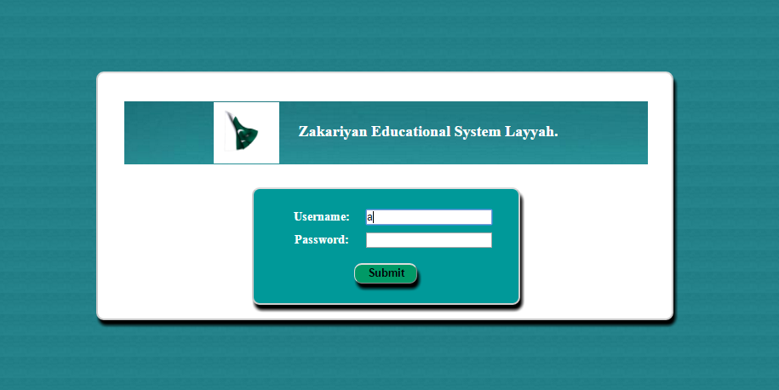

**5.1.2 Get student Admission:**

When user clicks on ***Get Admission Form***, a form like this will appear and user will enter student data in this form for admission.

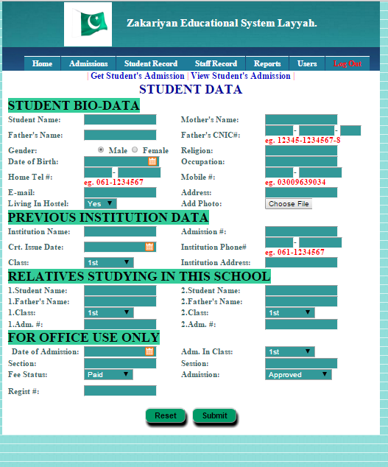

**5.1.3 Enter dues:**

When user clicks on ***Enter Dues Form,*** like this will show and he will enter required data and make challan for students.

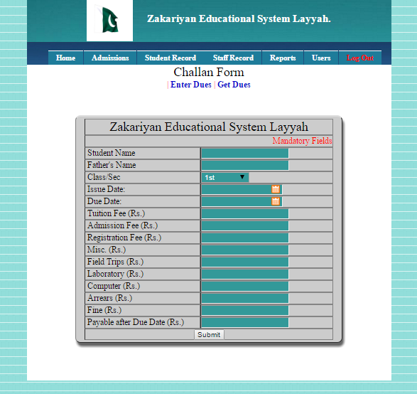

**5.1.4 Enter student data:**

When user clicks on ***Enter Student Data***, this form will show and willenter student bio data who has got admission in this school.

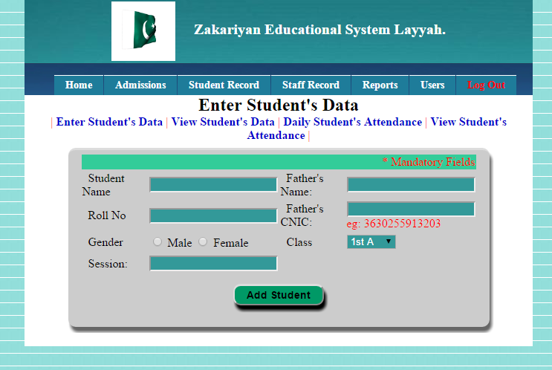

**5.1.5 Daily Class Attendance Sheet:**

When user clicks on ***Daily Class Attendance sheet***, this form will appear in which user will enter the record of attendance and make reports for whole class.

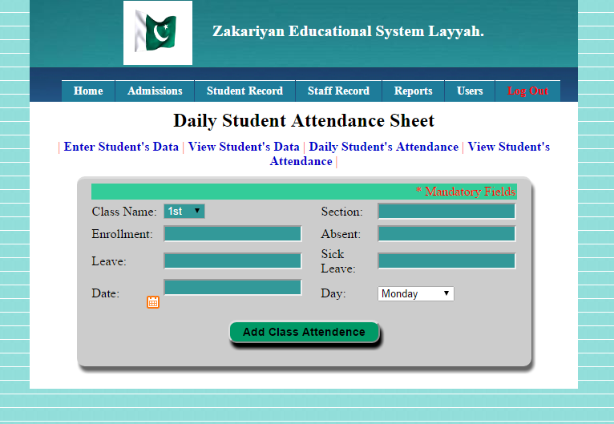

**5.1.6 Add New Staff:**

When user clicks on ***Add New Staff***, a form like this will appear on his screen in which he will enter staff and add staff members.

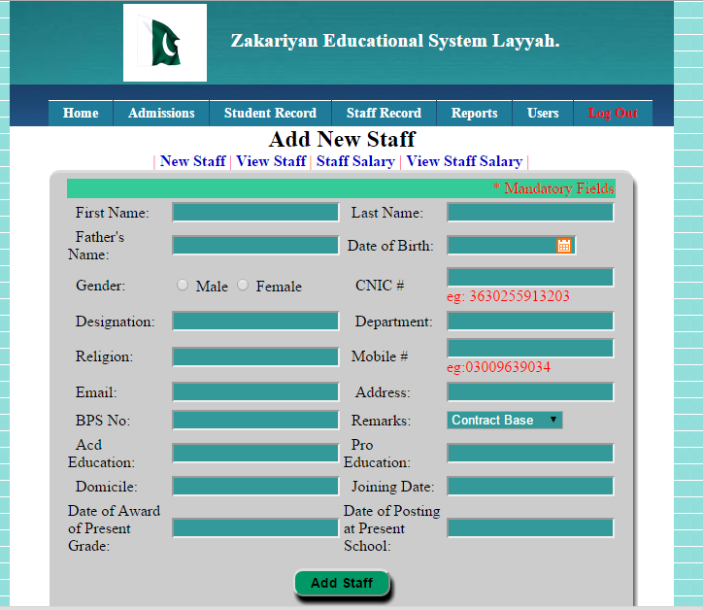

**5.1.7 Staff Salary:**

When user click on ***Staff Salary***, a form like this will appear. He will put different amount and make staff salary.

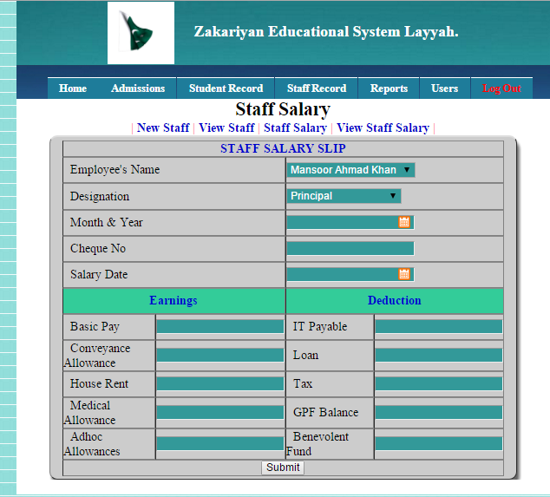

**5.1.8 Enter Student’s Marks:**

When user clicks on ***Enter Students Record***, this form will appear in which user will add marks of different subjects and make whole mark sheet of all students.

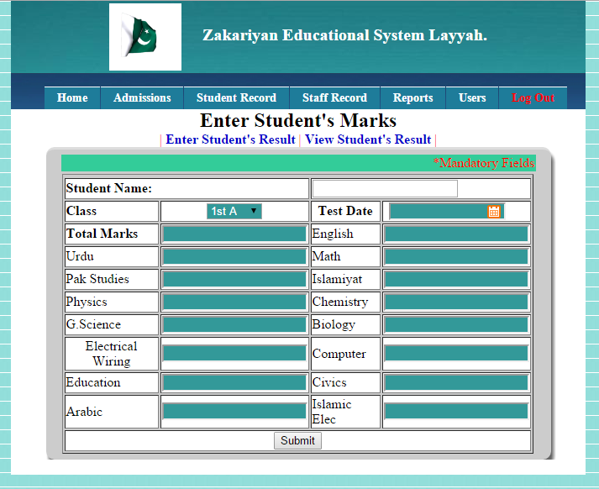

**5.1.9 Create New User:**

When user clicks on ***Create New Users***, this form will show in which he will fill the form add users who can log in this software.

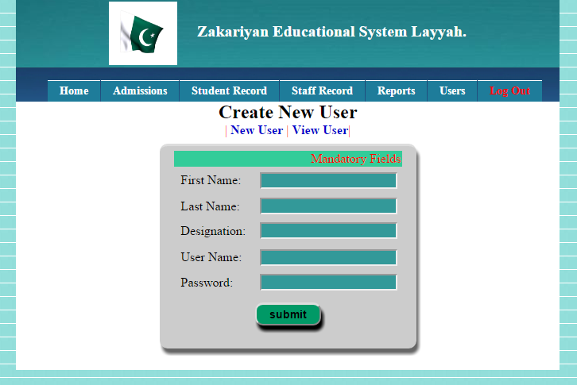

**5.2 Reports**

**5.2.1 Student Detail:**

This report is related to a student who got new admission in the school. This report contains student bio data like his full name, father name, gender, religion, date of birth, father name, CNIC and his previous school information and record which are only for office uses.

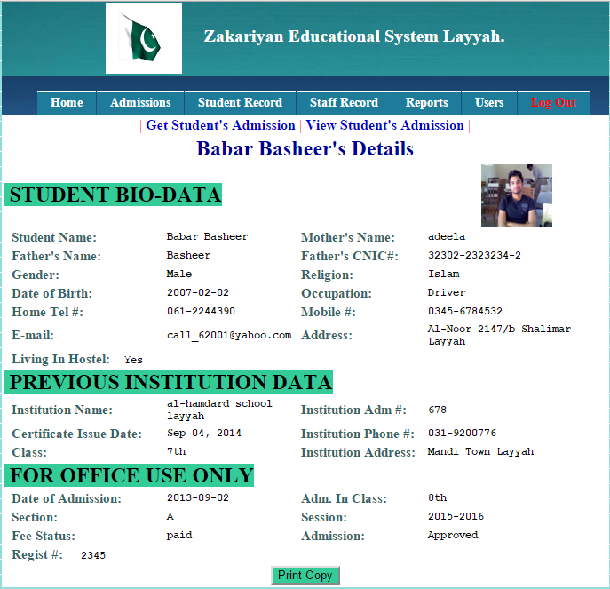

**5.2.2 Dues Challan:**

This report is related to student challan which contains institute name, student name, father name, class section, issue and due date, and fee of different component.

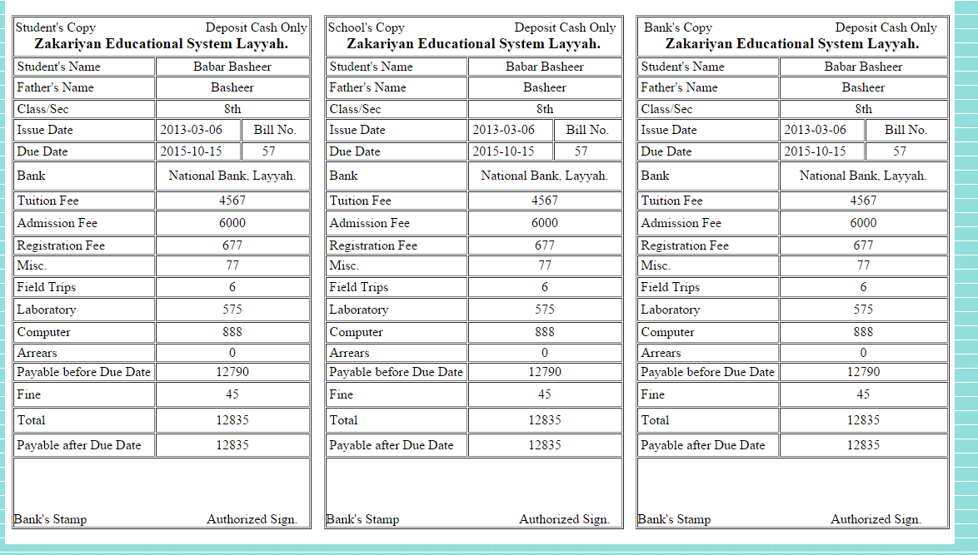

**5.2.3 Attendance Report:**

This report is about attendance of two days. Which count class name, section, enrollment, absent, leave, sick leave, present, total, date and day.

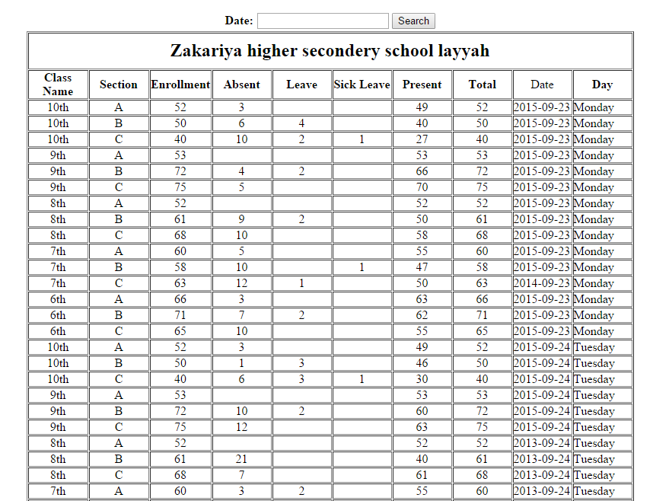

**5.2.4 Staff Detail Report:**

This report is related Individual staff member which contain his full name, father name gender, date of birth, CNIC#, qualification, BPS No, remarks, address etc.

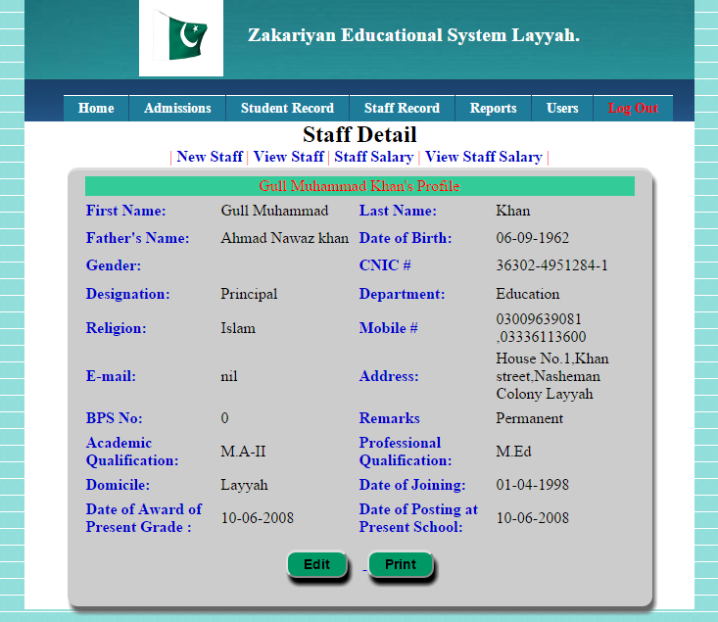

**5.2.5 Employee Profile Report:**

This report related to employee profiles in which whole record of employee exist.

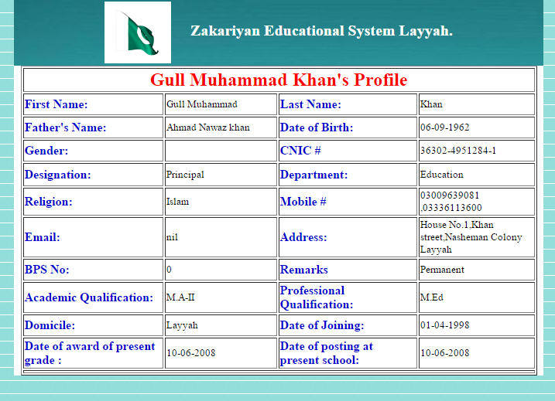

**5.2.6 Staff Salary Report:**

This report is related to staff salary which contains name, designation, cheque No., salary date and earnings and deduction.

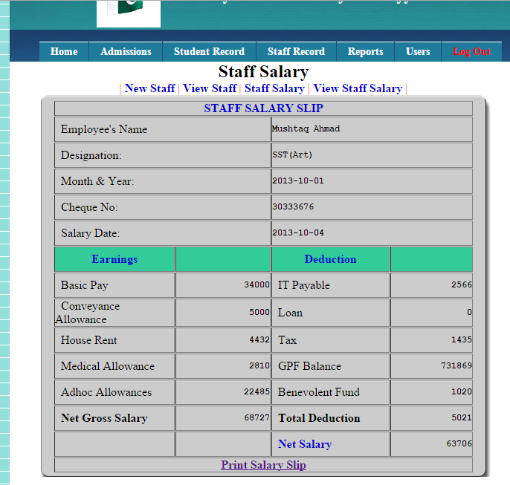

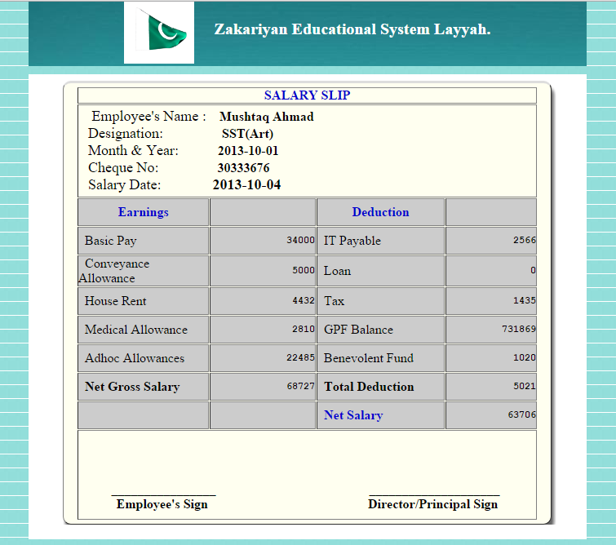

**5.2.7 Marks Sheet Report:**

This report is about marks sheet of students from different classes. In this report all the marks of subjects are added.

